**SPI**

Serial peripheral interconnect, controls the device through 5 pins in which 4 of the pins are shared.

* Direction of data flow is one direction

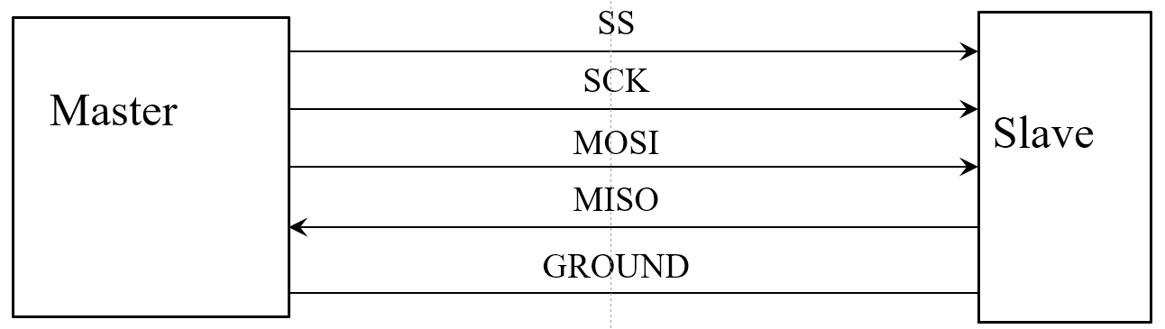

***Master supplies***

* clock signal
* Slave select line
* Outputs data on MOSI

***Slave***

* Return data on MISO

SPI provide synchronous serial communication in a master-slave relation

* One device (KL46Z: master) set the speed and controls when data be sent & received.
* Other device: operate under control of the master devices



C= SCK (SCKL) ->Slave clock

O= MOSI -> Master Out Slave In

I= MISO -> Master In Slave Out

S= SS -> Slave Select // activate or deactivates the slave device

===>>>> mbed.org/ SPI function ignores the SS line and required to control SS line as DigitalOut.

To use multiple slave on a single bus:

* we must provide the equivalent of an SS line for each device
* Separate select/control line for each device so that we never precaution 2 devices simultaneously
* The SPI devices disconnect their MISO pins when they are not selected 🡺 many devices do not do this step🡺 Need additional circuitry to prevent this issue.

**Interrupts**

Is an action caused by a source outside of the regular program flow

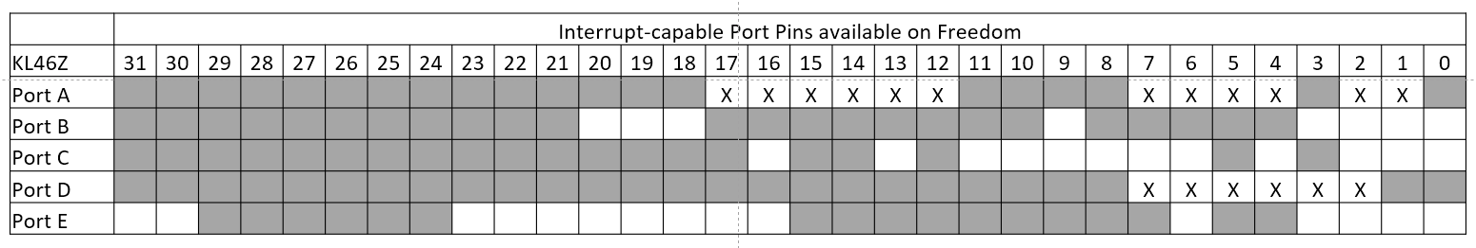It cause the program flow to pause while the interruption condition is handled

PWM

Pulse Width Modulation

T

D*T

T= period : are measured in units of time per cycle

F= frequency

T = 1/*f* or *f* = 1/T

* The mbed function PwmOut allows for the automatic generation of PWM signals on a number of output pins.
* For the PwmOut class, the PWM signal is specified by indicating the period (T) and the pulse width in terms of time. Note that the pulse width must not exceed the period.
* If given the duty cycle, 0 <= D <= 1, the pulse width is calculated as D*T.
* On the KL46Z, only certain pins are PWM capable and the total number of unique PWM signals is limited.



* Channel 0.0 🡪 PTC1
* Channel 0.1 🡪 PTA4, PTC2
* Channel 0.2 🡪 PTA5, PTD2, Red LED (PTE29)
* Channel 0.3 🡪 PTA6, PTC4, PTD3, PTE30
* Channel 0.4 🡪 PTA7, PTC8, PTD4, PTE31
* Channel 0.5 🡪 PTC9, PTD5, Green LED (PTD5)
* Channel 1.0 🡪 PTA12, PTB0, PTE20
* Channel 1.1 🡪 PTA13, PTB1, PTE21
* Channel 2.0 🡪 PTA1, PTB2, PTE22
* Channel 2.1 🡪 PTA2, PTB3, PTE23
* The KL46Z has a total of 10 available PWM channels arranged as PWM unit 0 with 6 channels, PWM unit 1 with 2 channels, and PWM unit 2 with 2 channels. These can be routed to various pins.
* All channels in a given PWM unit share the same period counter so they all must generate the same frequency output. The only difference available is the pulse width/duty cycle.
* So, channels 0.0, 0.1, 0.2, 0.3, 0.4, and 0.5 share a common period. Likewise channels 1.0 and 1.1 share a common period and channels 2.0 and 2.1 share a common period.
* The mbed.org PWM functions which set periods for these channels do not make it obvious that changing the period for one channel simultaneously changes the period for all channels on that unit.
* To generate two different frequencies for DTMF, you must use channels from two different PWM units.

**Serial Port**

The mbed Serial Port uses pins labeled USBTX and USBRX.

The schematic shows that these are really PTA1=USBRX, PTA2=USBTX.

This means that the OpenSDA chip is taking the KL46Z PTA1/PTA2, i.e. UART0, and rerouting it through the OpenSDA USB interface.

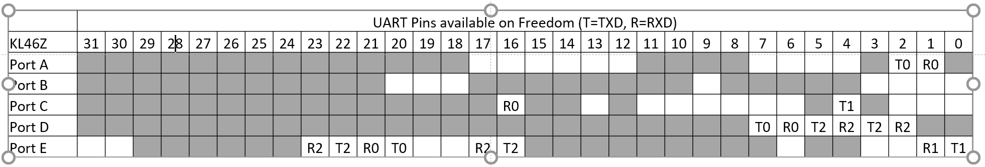

Degital ports

--> Digital_IN

•The DigitalIn class allows a single pin to be used to input a single bit digital logic value, either logic 0 or logic 1.

•The KL46Z datasheet indicates that for a 3.3V power supply, the acceptable ranges of input voltage are:

•This means 1.155 V <= VIN <= 2.145V is the range of undefined inputs

--> Digital_OUT

The DigitalOut class allows a single pin to be used to output a single bit digital logic value, either logic 0 or logic 1

•0.5 V <= VOUT <= 2.8V should not happen unless the output is overloaded and the output pin cannot provide sufficient current.